Class Diagram(Version 1)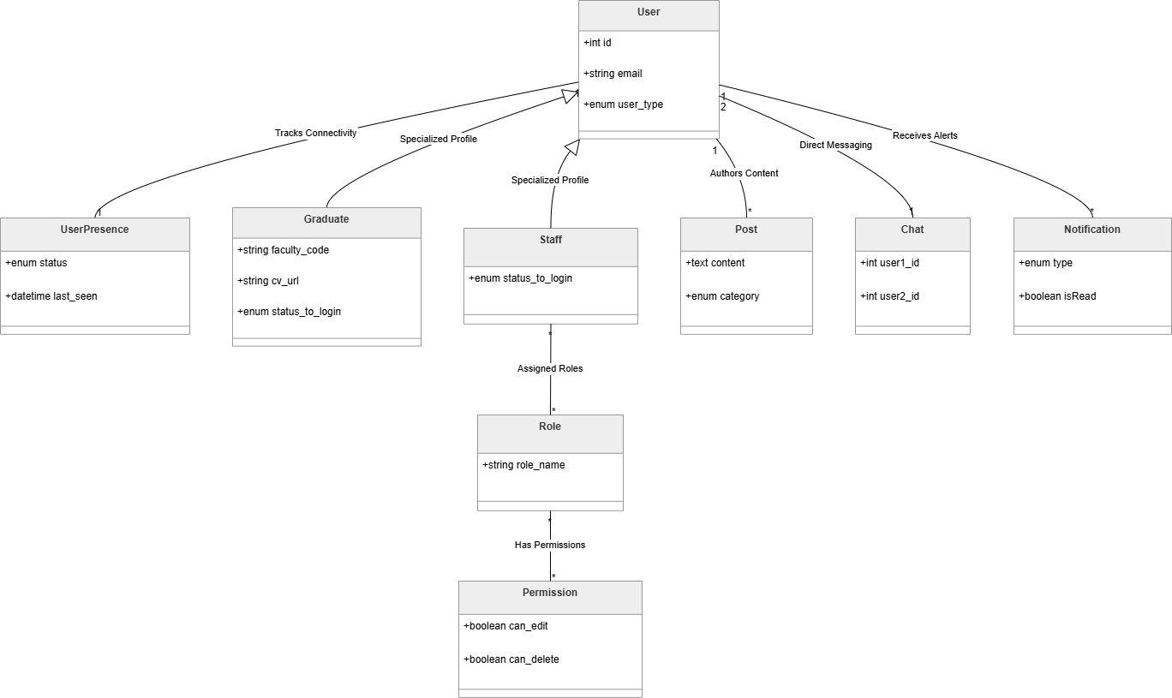
Class Diagram(Version 2)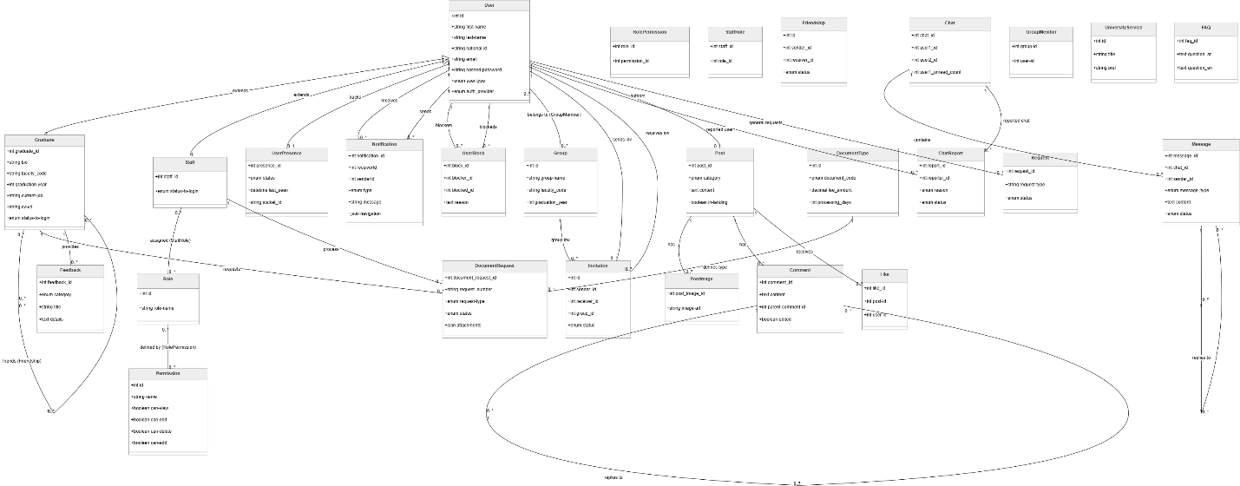

ERD (version 1)

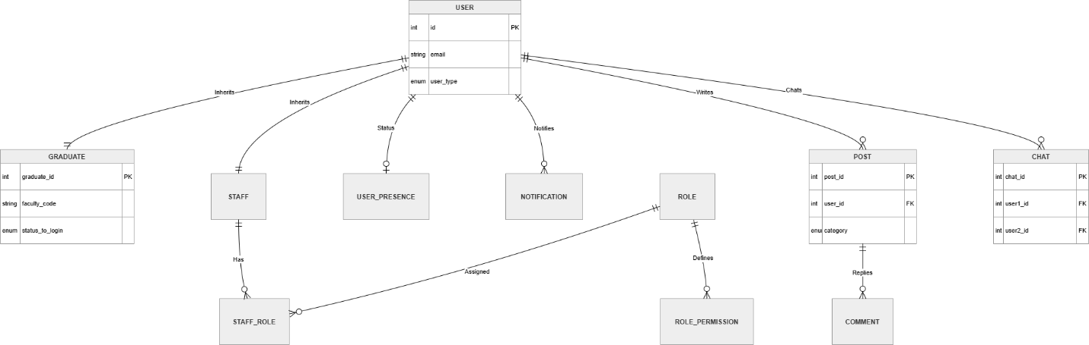
ERD (version 2)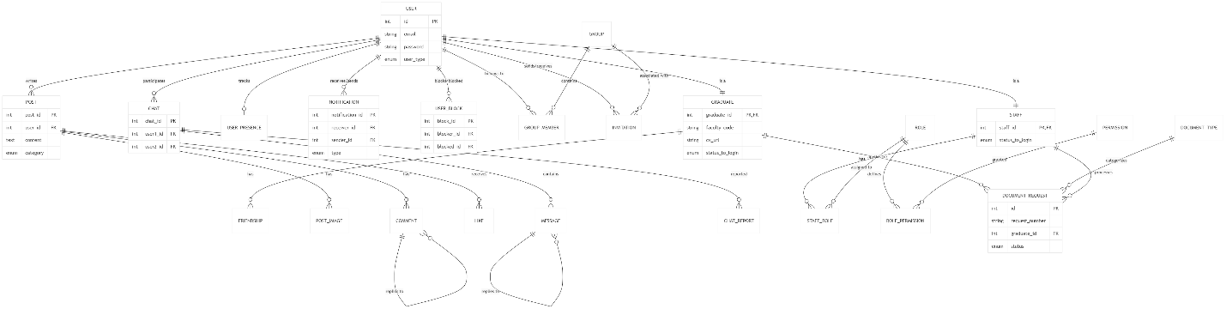
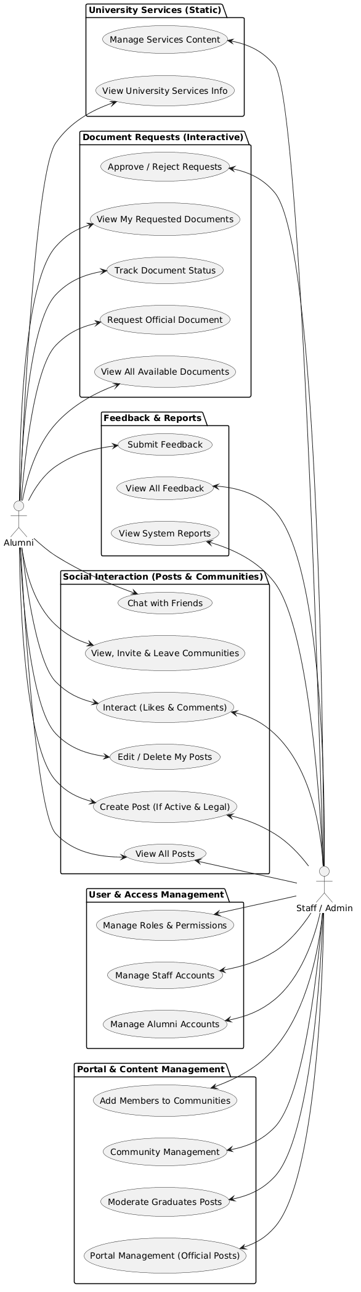
Use Case
Sequence Diagram(Alumni)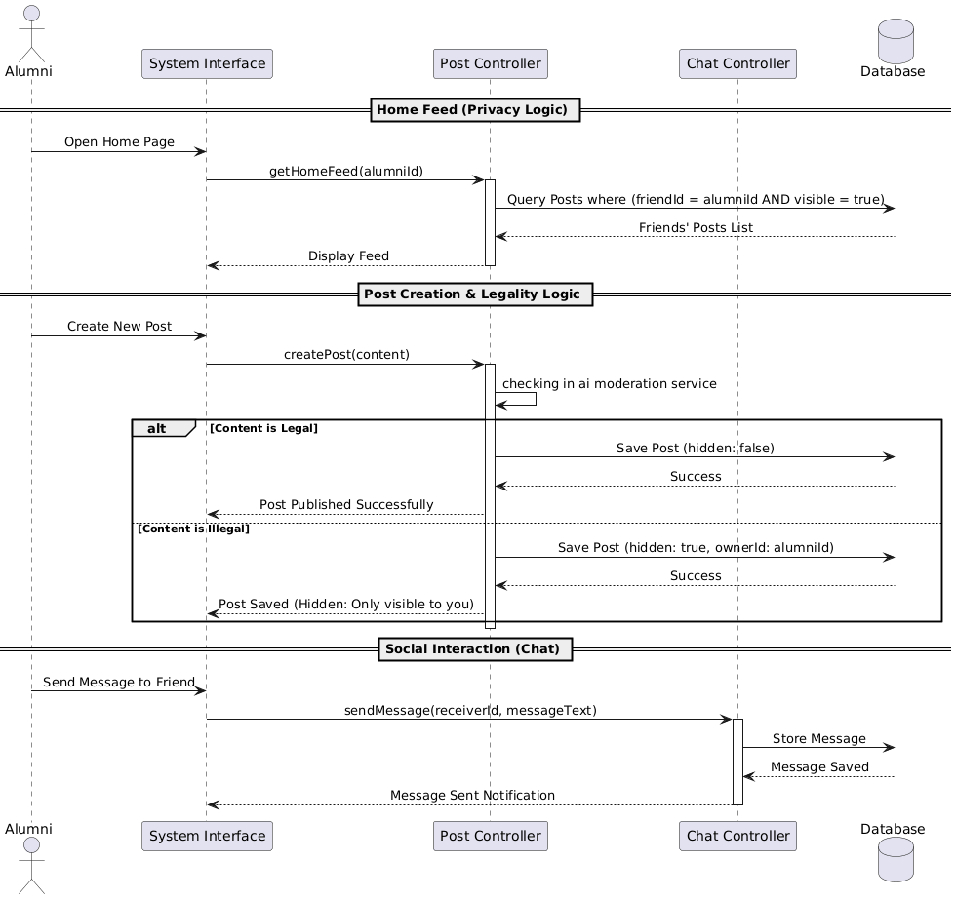
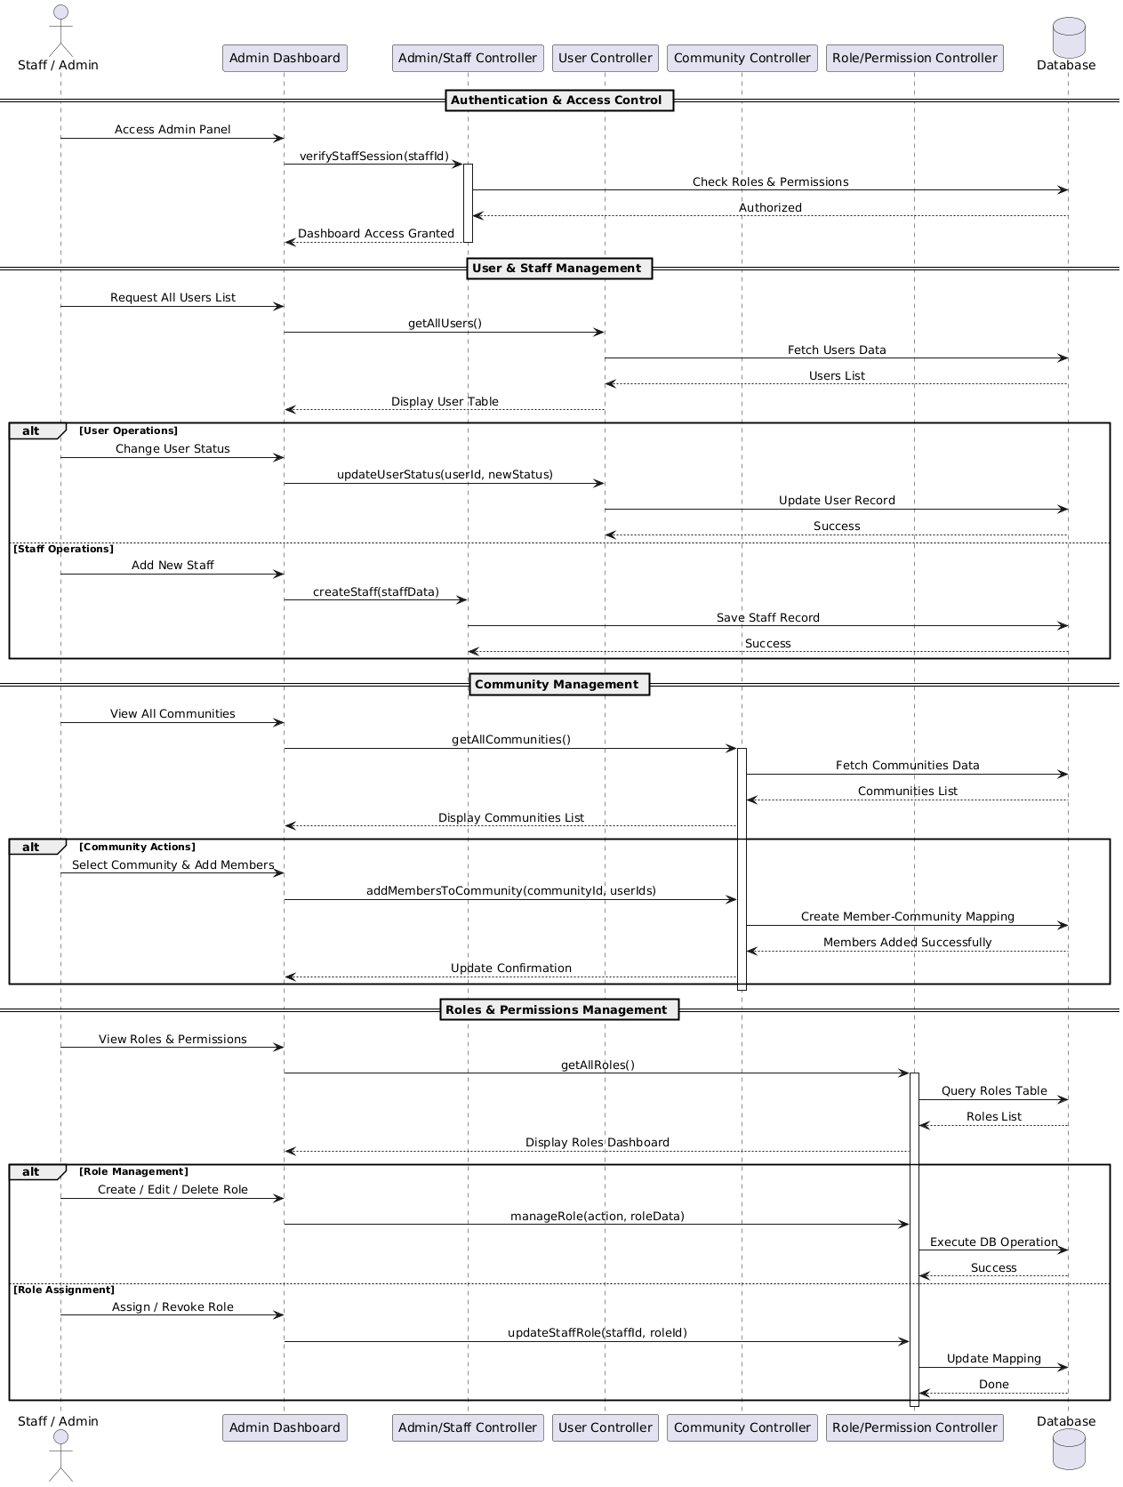
Sequence Diagram--Admin/staff
Sequence Diagram --chat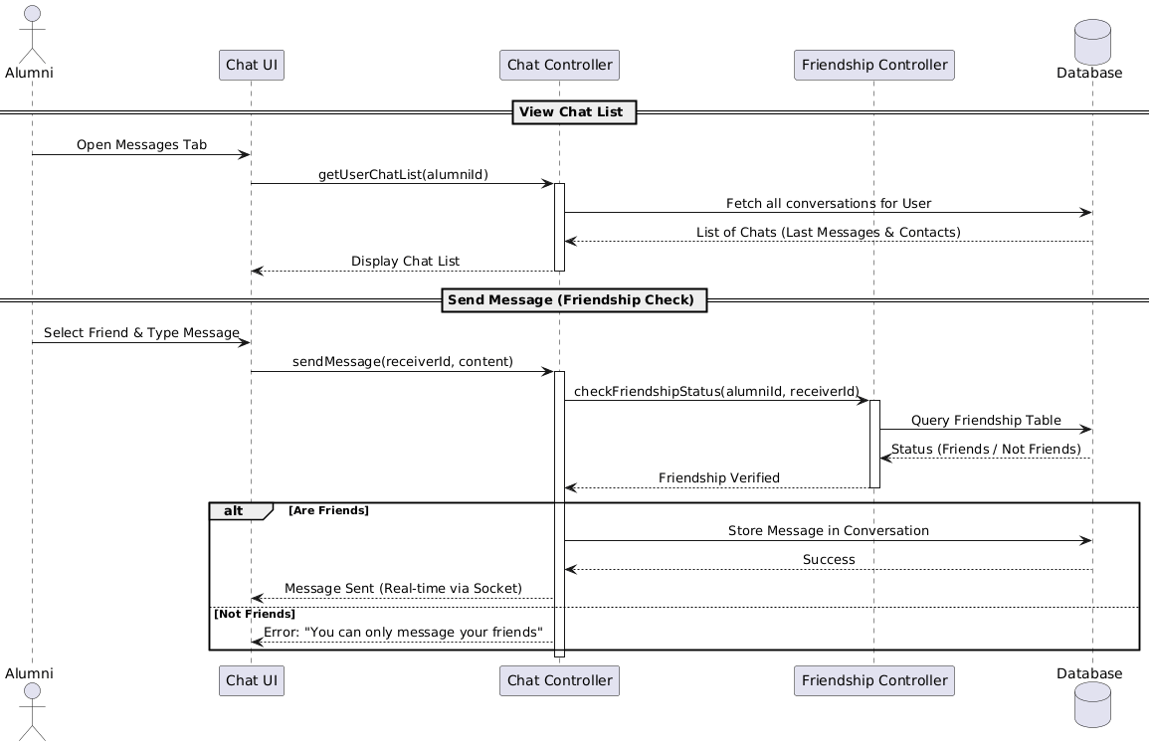

Sequence Diagram—Create Post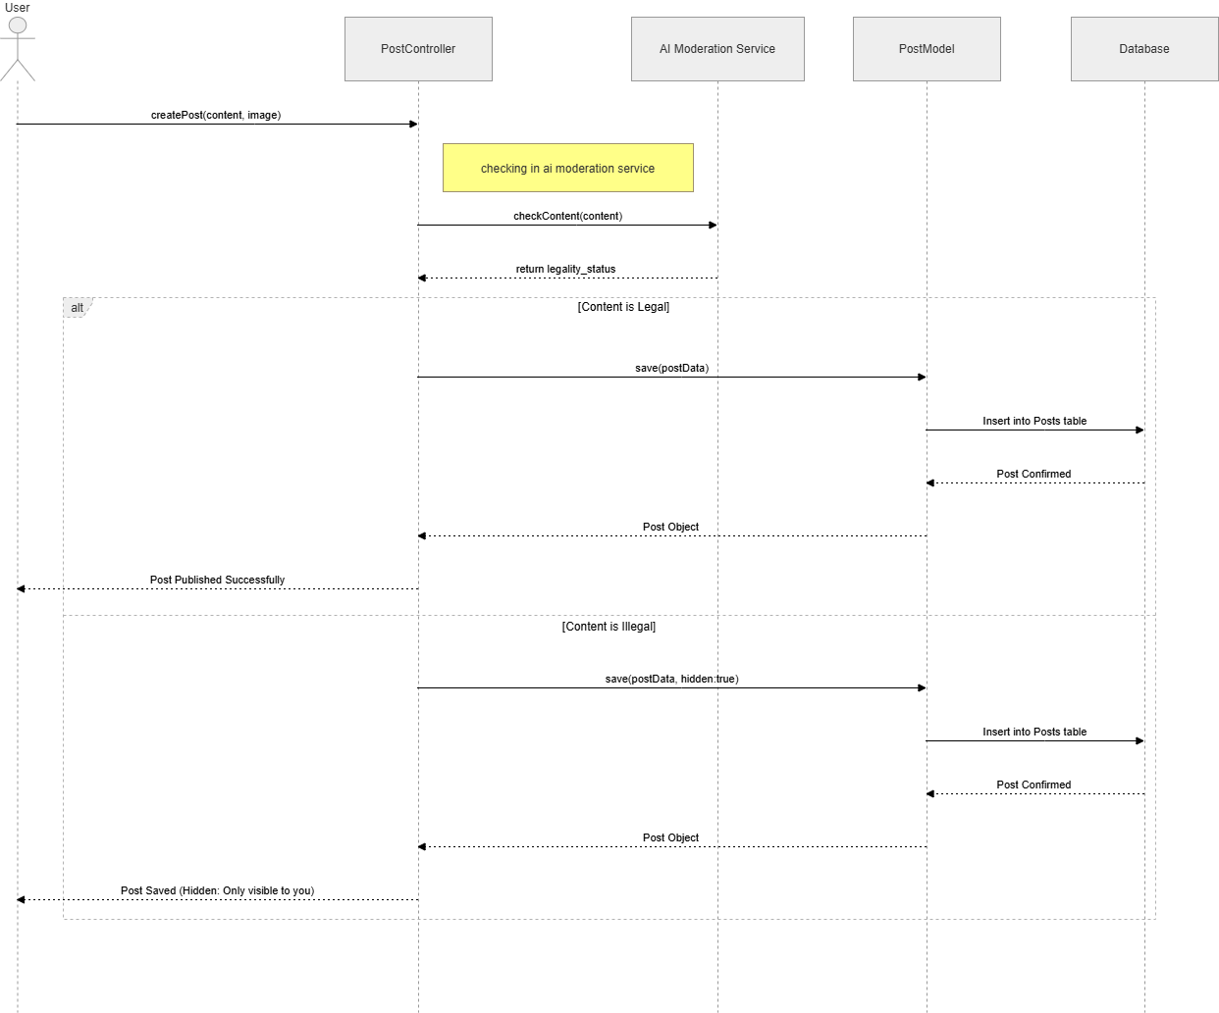

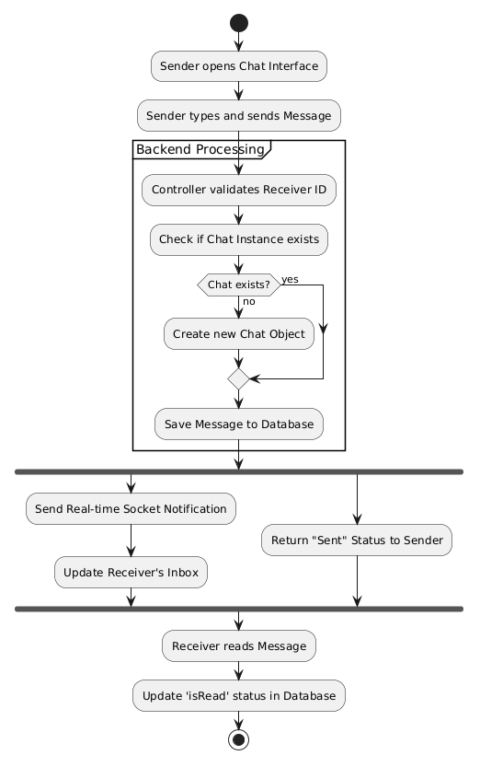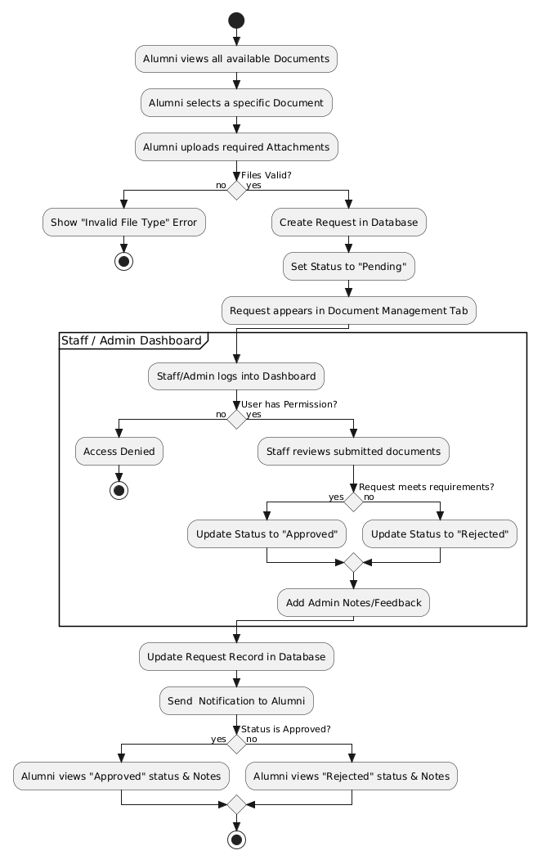
Activity Diagram--chat
Activity Diagram—Document Request
(document Request)

Activity Diagram--
Authentication and Authorization
